**WITH NOISE AND WITHOUT FILTER**

**Image set:**

|  |
| --- |
| **Image 1:-0.1 % Noise** |

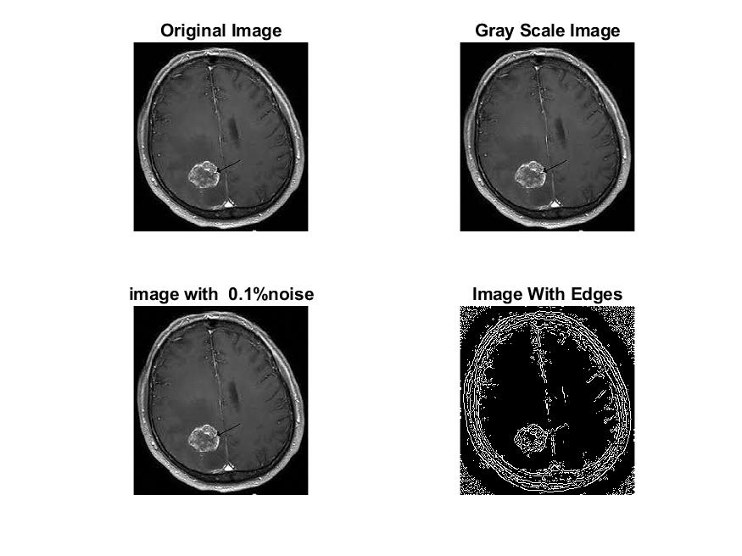

**Image 2:-10 % Noise**

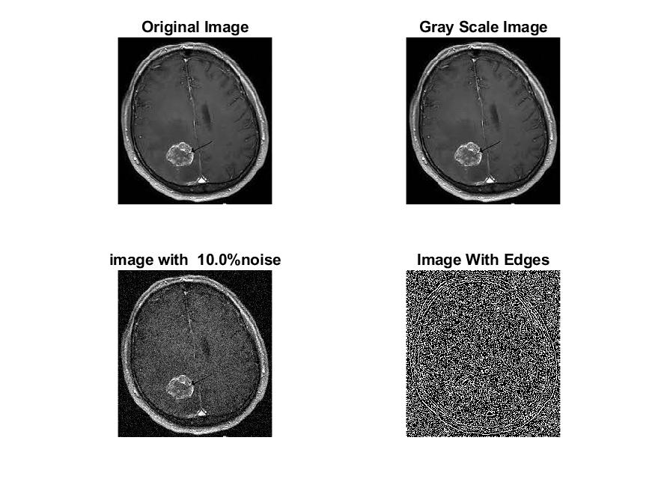

**Image 3:-20 % Noise**

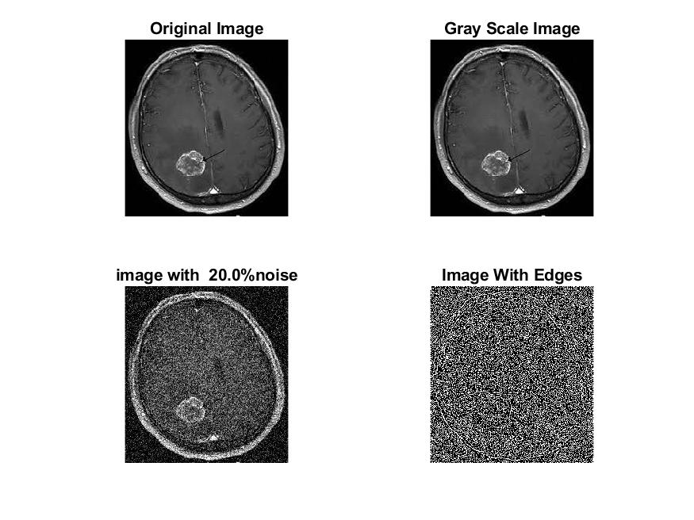

**Image 4:-30 % Noise**

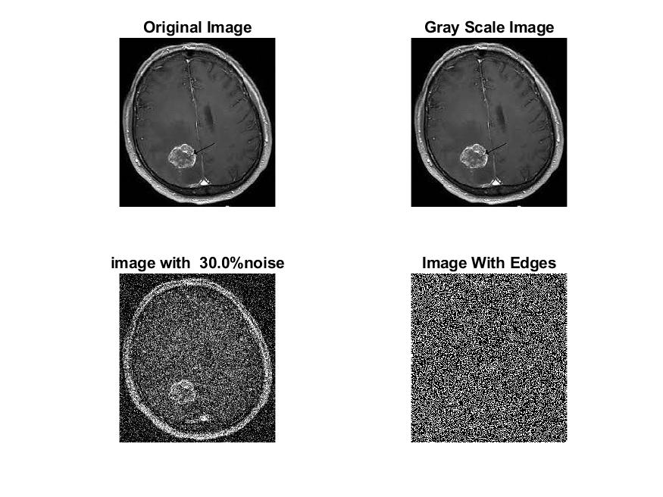

|  |
| --- |
| **Image 5:-40 % Noise** |

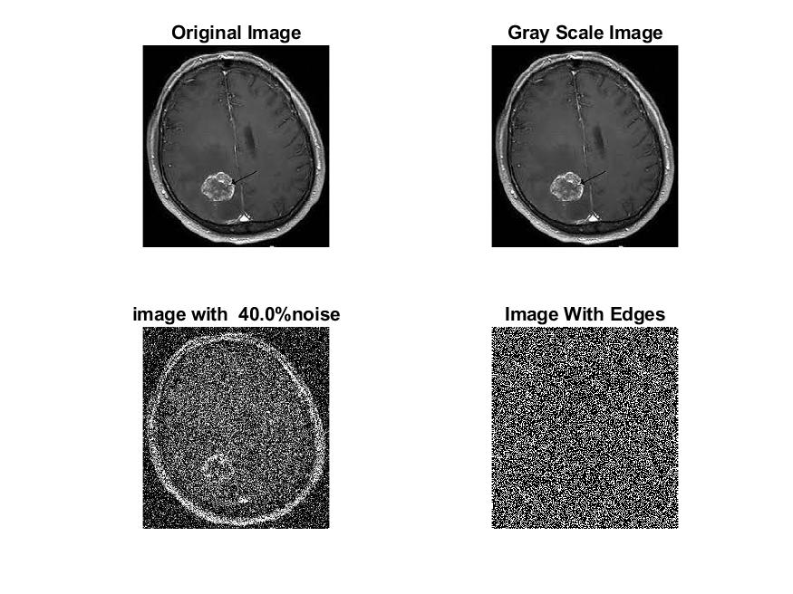

**Image 6:-50 % Noise**

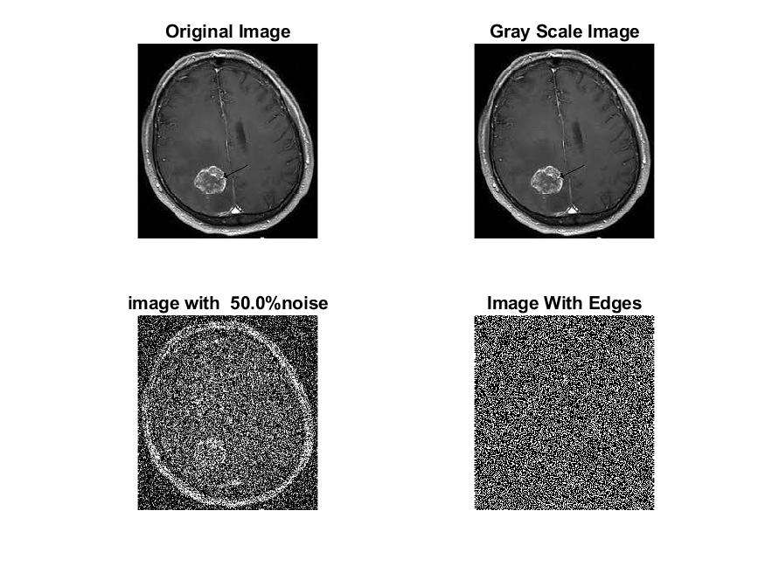

**Image 7:-60 % Noise**

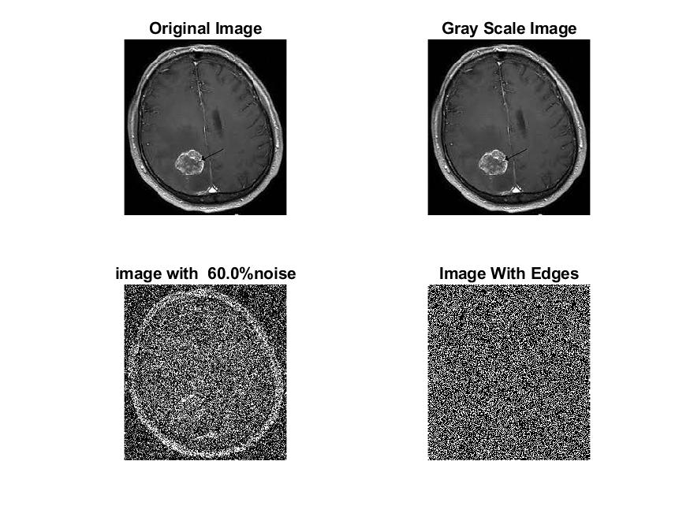

**Image 8:-70 % Noise**

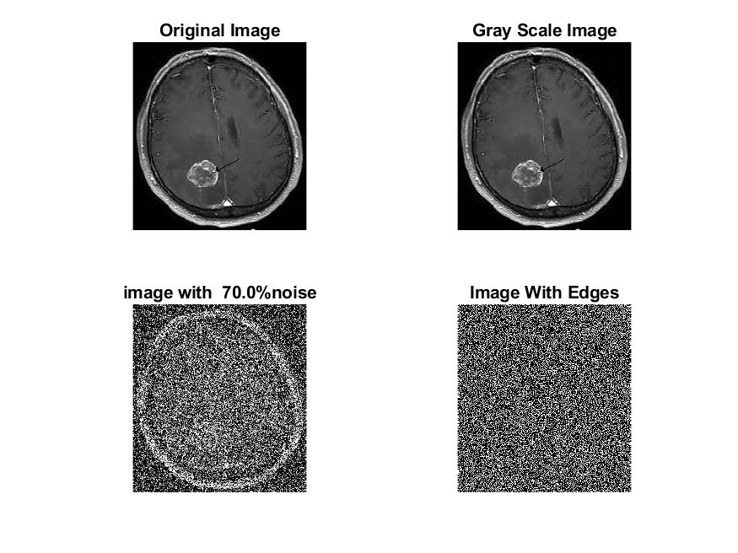

**Image 9:-80 % Noise**

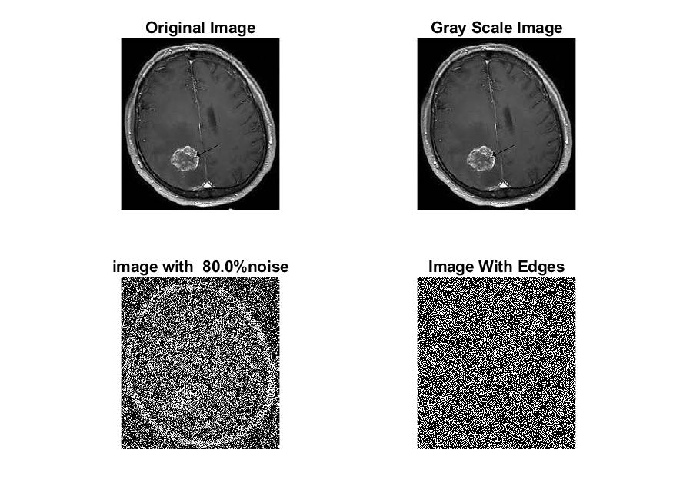

**DATA FILES**

**Image 1:-Noise0.1**

Original image ideal values:

IM1 image entropy:5.906197e-01

IM1 image mean:0.142450

Ground truth image entropy:0.746959

Ground truth image mean:0.212884

entropy between imt and im1 :0.657909

MSE between imt and im1 :0.269745

Average Difference between imt and im1 :0.070434

Maximum Difference between imt and im1 :1.000000

True Positive values:2163.000000

False Positive values: 5037.000000

True Negative values:34747.000000

False Negative values:8597.000000

Accuracy value: 0.730255

F Measure values:0.240869

Peak Signal-to Noise Ration value: 5.690463

Signal-to Noise Ration value: -1.744798

percentage of pixels that were correctly detected (Pco): 0.201022

The percentage of pixels that were not detected (Pnd):0.798978

the percentage of false alarm: (Pfa):0.468123

Euclidean Distance Value :19.143361

**Image 2:-Noise10**

Original image ideal values:

IM1 image entropy:9.185331e-01

IM1 image mean:0.333571

Ground truth image entropy:0.746959

Ground truth image mean:0.212884

entropy between imt and im1 :0.605037

MSE between imt and im1 :0.416865

Average Difference between imt and im1 :-0.120687

Maximum Difference between imt and im1 :1.000000

True Positive values:3275.000000

False Positive values: 13585.000000

True Negative values:26199.000000

False Negative values:7485.000000

Accuracy value: 0.583135

F Measure values:0.237147

Peak Signal-to Noise Ration value: 3.800051

Signal-to Noise Ration value: 1.950453

percentage of pixels that were correctly detected (Pco): 0.194247

The percentage of pixels that were not detected (Pnd):0.443950

the percentage of false alarm: (Pfa):0.805753

Euclidean Distance Value :18.470595

**Image 3:-Noise20**

Original image ideal values:

IM1 image entropy:9.226832e-01

IM1 image mean:0.337785

Ground truth image entropy:0.746959

Ground truth image mean:0.212884

entropy between imt and im1 :0.592717

MSE between imt and im1 :0.411424

Average Difference between imt and im1 :-0.124901

Maximum Difference between imt and im1 :1.000000

True Positive values:3519.000000

False Positive values: 13554.000000

True Negative values:26230.000000

False Negative values:7241.000000

Accuracy value: 0.588576

F Measure values:0.252865

Peak Signal-to Noise Ration value: 3.857107

Signal-to Noise Ration value: 2.004976

percentage of pixels that were correctly detected (Pco): 0.206115

The percentage of pixels that were not detected (Pnd):0.424120

the percentage of false alarm: (Pfa):0.793885

Euclidean Distance Value :19.653495

**Image 4:-Noise30**

Original image ideal values:

IM1 image entropy:9.261573e-01

IM1 image mean:0.341406

Ground truth image entropy:0.746959

Ground truth image mean:0.212884

entropy between imt and im1 :0.586661

MSE between imt and im1 :0.410375

Average Difference between imt and im1 :-0.128522

Maximum Difference between imt and im1 :1.000000

True Positive values:3637.000000

False Positive values: 13619.000000

True Negative values:26165.000000

False Negative values:7123.000000

Accuracy value: 0.589625

F Measure values:0.259637

Peak Signal-to Noise Ration value: 3.868190

Signal-to Noise Ration value: 2.051279

percentage of pixels that were correctly detected (Pco): 0.210767

The percentage of pixels that were not detected (Pnd):0.412784

the percentage of false alarm: (Pfa):0.789233

Euclidean Distance Value :20.117224

**Image 5:-Noise40**

Original image ideal values:

IM1 image entropy:9.232777e-01

IM1 image mean:0.338398

Ground truth image entropy:0.746959

Ground truth image mean:0.212884

entropy between imt and im1 :0.587331

MSE between imt and im1 :0.407882

Average Difference between imt and im1 :-0.125514

Maximum Difference between imt and im1 :1.000000

True Positive values:3624.000000

False Positive values: 13480.000000

True Negative values:26304.000000

False Negative values:7136.000000

Accuracy value: 0.592118

F Measure values:0.260121

Peak Signal-to Noise Ration value: 3.894652

Signal-to Noise Ration value: 2.012854

percentage of pixels that were correctly detected (Pco): 0.211880

The percentage of pixels that were not detected (Pnd):0.417212

the percentage of false alarm: (Pfa):0.788120

Euclidean Distance Value :20.228380

**Image 6:-Noise50**

Original image ideal values:

IM1 image entropy:9.261198e-01

IM1 image mean:0.341366

Ground truth image entropy:0.746959

Ground truth image mean:0.212884

entropy between imt and im1 :0.588464

MSE between imt and im1 :0.411720

Average Difference between imt and im1 :-0.128482

Maximum Difference between imt and im1 :1.000000

True Positive values:3602.000000

False Positive values: 13652.000000

True Negative values:26132.000000

False Negative values:7158.000000

Accuracy value: 0.588280

F Measure values:0.257157

Peak Signal-to Noise Ration value: 3.853975

Signal-to Noise Ration value: 2.050775

percentage of pixels that were correctly detected (Pco): 0.208763

The percentage of pixels that were not detected (Pnd):0.414860

the percentage of false alarm: (Pfa):0.791237

Euclidean Distance Value :19.916246

**Image 7:-Noise60**

Original image ideal values:

IM1 image entropy:9.269428e-01

IM1 image mean:0.342236

Ground truth image entropy:0.746959

Ground truth image mean:0.212884

entropy between imt and im1 :0.587383

MSE between imt and im1 :0.411760

Average Difference between imt and im1 :-0.129353

Maximum Difference between imt and im1 :1.000000

True Positive values:3623.000000

False Positive values: 13675.000000

True Negative values:26109.000000

False Negative values:7137.000000

Accuracy value: 0.588240

F Measure values:0.258251

Peak Signal-to Noise Ration value: 3.853558

Signal-to Noise Ration value: 2.061836

percentage of pixels that were correctly detected (Pco): 0.209446

The percentage of pixels that were not detected (Pnd):0.412591

the percentage of false alarm: (Pfa):0.790554

Euclidean Distance Value :19.985435

**Image 8:-Noise70**

Original image ideal values:

IM1 image entropy:9.261761e-01

IM1 image mean:0.341425

Ground truth image entropy:0.746959

Ground truth image mean:0.212884

entropy between imt and im1 :0.586764

MSE between imt and im1 :0.410474

Average Difference between imt and im1 :-0.128541

Maximum Difference between imt and im1 :1.000000

True Positive values:3635.000000

False Positive values: 13622.000000

True Negative values:26162.000000

False Negative values:7125.000000

Accuracy value: 0.589526

F Measure values:0.259485

Peak Signal-to Noise Ration value: 3.867143

Signal-to Noise Ration value: 2.051530

percentage of pixels that were correctly detected (Pco): 0.210639

The percentage of pixels that were not detected (Pnd):0.412876

the percentage of false alarm: (Pfa):0.789361

Euclidean Distance Value :20.104447

**Image 9:-Noise80**

Original image ideal values:

IM1 image entropy:9.297302e-01

IM1 image mean:0.345224

Ground truth image entropy:0.746959

Ground truth image mean:0.212884

entropy between imt and im1 :0.583920

MSE between imt and im1 :0.412096

Average Difference between imt and im1 :-0.132340

Maximum Difference between imt and im1 :1.000000

True Positive values:3690.000000

False Positive values: 13759.000000

True Negative values:26025.000000

False Negative values:7070.000000

Accuracy value: 0.587904

F Measure values:0.261619

Peak Signal-to Noise Ration value: 3.850012

Signal-to Noise Ration value: 2.099583

percentage of pixels that were correctly detected (Pco): 0.211473

The percentage of pixels that were not detected (Pnd):0.405181

the percentage of false alarm: (Pfa):0.788527

Euclidean Distance Value :20.187450